


ENGLISH ASSIGNMENT 1.1

Topic: A cultural event-
HANAMI FESTIVAL

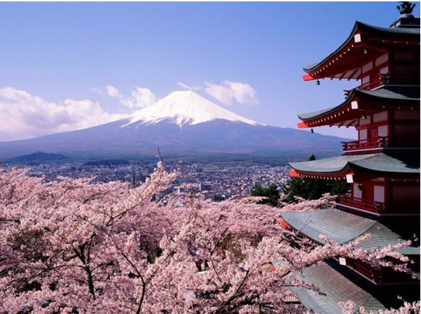

Teacher : | NguyenNH
Student : | Nguyen Quoc Tuan
SID : | PH08378
Class : | ENT1123.1

OUTLINE

- INTRODUCTION
Introduction to Hanami Festival
- BODY
1. All of Hanami Festival
2. Traditional Food - Cultural Activities
3. My Experience and Feelings of Hanami
- CONCLUSION

Hanami and The Last words

